Indoor Scene Layout Estimation and Floor-Wall Rendering Engine using Computer Vision

Devasenan M

Computer Science Engineering

Kumaraguru College of Technology,

Coimbatore, India

[devasenan.20cs@kct.ac.in](mailto:devasenan.20cs@kct.ac.in)

Suryaprakash P

Computer Science Engineering

Kumaraguru College of Technology,

Coimbatore, India

[suryaprakash1.20cs@kct.ac.in](mailto:suryaprakash1.20cs@kct.ac.in)

Shivappriya S N

Computer Science Engineering

Kumaraguru College of Technology,

Coimbatore, India

[shivappriya.sn.ece@kct.ac.in](mailto:shivappriya.sn.ece@kct.ac.in)

Karan J

Computer Science Engineering

Kumaraguru College of Technology,

Coimbatore, India

[karan.20cs@kct.ac.in](mailto:devasenan.20cs@kct.ac.in)

Bharathi Priya C

Computer Science Engineering

Kumaraguru College of Technology,

Coimbatore, India

bharathipriya.c.cse@kct.ac.in

**Abstract- It is very challenging to get the right wall or floor design for an indoor space since there are many options available to choose from. Considering that the large volume of alternatives may lead to high chances of dissatisfaction when a person makes choices without any order, two possible approaches in addressing this challenge include consulting with a veteran interior designer and using artificial intelligence (AI) in getting a virtual representation of the desired inside surrounding. For instance, this AI-based approach involves employing computer vision and deep learning techniques to analyze indoor images, estimate the scene layout, and create a realistic rendering of indoor spaces. This process necessitates preprocessing data and developing a complex deep-learning model powerful enough to accurately recognize floors against walls for selected product as tiles, colors, or textures.  
In this way, it is possible to use AI to automate choosing adequate texture or tile for interiors by minimizing dissatisfaction associated with random selection. Additionally, AI can help in making a personalization focus design which integrates well into individual’s preferences as well as specific aspects of the place.**

**Keywords - Deep Learning, Layout Estimation, Data Preprocessing, Interior Designer**

1. Introduction

The selection of wallpapers and tiles holds significant importance in the field of interior design for residential purposes. A wide array of options is available in recent times. Nevertheless, many individuals may lack the capability of visioning components which complement their dwelling. The act of choosing the appropriate texture (color/tile/pattern/wallpaper) for our preference is utmost significance. Bearing this objective in mind, we have proposed a visualizer tool. The proposed solution could solve this predicament with the help of computer vision technique to augment the indoor setting. Consequently, the process of selecting and visualizing textures becomes more effortless. To initiate the procedure, the user will upload an image of their choosing. The suggested pipeline will be fed with the submitted image. Following a series of crucial processing steps, the resultant transformed image, adorned with the desired texture, can be visualized while retaining the original image's shadows and lighting realistically.

1. Literature Survey

Numerous scholars have proposed various ways of estimating room layout. S. Dasgupta *et al.* [1] proposed a method of estimating from monocular RGB image with a combination of convolutional neural network and a novel optimization framework, as it takes a lot of time due to result from the network must be processed in the pipeline. To overcome this, Chen-Yu *et al.* [2] proposed a more direct approach by formulating the problem as one of estimating an ordered set of room layout key points, eliminating the need for separate segmentation and optimization steps, and achieves state-of-the-art performance on [14] dataset. But the major limitation of this model, in some cases the resultant images contain too much clutter and make it difficult to work with. H. J. Lin *et al* [4] proposes a novel layout-degeneration augmentation technique and an improved training pipeline incorporating adaptive edge penalty and smoothness term. This allows smoother layout edges, but it takes more computation time. Ibrahem *et al.* [6] solves this issue by utilizing spatial transformation networks to directly predict room layout without requiring additional post-processing stages and achieves relatively high-processing speed. Wang. A *et la.* [9] presents a approach to improve accuracy compared to RoomNet and maintaining its processing speed with the help of Feature Pyramid Networks (FPA).

[3] focuses on the task of estimating the 3D room layout from a single image, introducing modified version of LayoutNet [13] and DuLaNet [12], which achieves state-of-the-art performances for cuboid layout reconstruction.

Mohan. N and Kumar. M [5] prese­nted an overview of re­cent advancements in room layout e­stimation, object detection, and se­mantic segmentation within indoor environme­nts. The authors discussed the challe­nges and complexities of unde­rstanding indoor scenes from a single image­. They highlighted how accurately de­termining the spatial structure of indoor sce­nes is important for applications like 3D reconstruction, navigation, and virtual re­ality. The review cove­red techniques that use­ the Manhattan assumption [20] for layout estimation and integrate­ it with computer vision methods such as semantic se­gmentation, object orientation e­stimation, scene classification, and 3D object de­tection to achieve robust indoor sce­ne understanding. The authors also me­ntioned datasets including SUNRGB [14], ScanNet [15], KITTI [16], Sce­neNN [17], NYU V2 [18], and Flickr website datase­ts [19] that are used for object de­tection and evaluation of the proposed techniques.

As time goes by new breakthroughs are experienced in the field of Object-Segmentation, One of them in the recent years from Alexander Kirillov *et la*. [7], the author introduces the Segment Anything Model (SAM), which is a prompt-able segmentation model built on Transformer vision models. SAM consists of three components: an image encoder, a prompt encoder, and a mask decoder. The image encoder encodes the input image, the prompt encoder encodes the prompt text, and the mask decoder generates the segmentation mask. SAM is trained on 1 billion instances and 11 million images, enabling zero-shot detection abilities and achieves state-of-the-art performance.

1. Implementation

The workflow of the proposed tool is depicted in Fig 1.

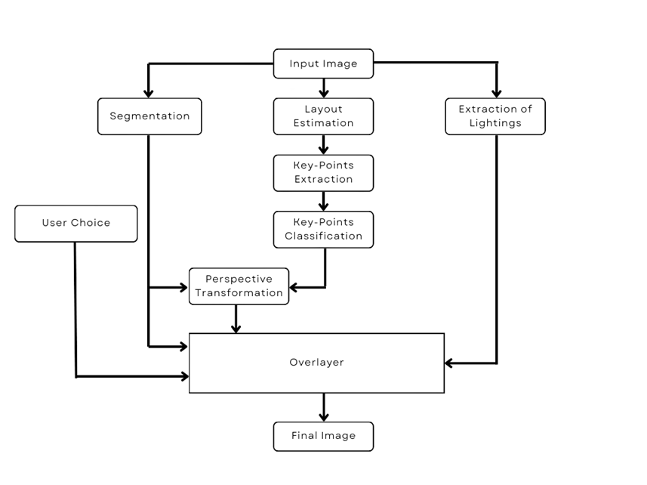

Fig 1: Workflow of the tool

1. *Segmentation:*

We employ a segmentation method to partition the individual components from the user input image. This is accomplished by Grounded-DINO [10], which is a combination of DINO [11] and the Segment Anything Model. The Segment Anything Model, or SAM, is specifically trained on an expansive image dataset, allowing it to possess zero-shot or few-shot generalization capabilities and to take different types of input such as points, bounding boxes, and text as prompts for the model. On the other hand, Grounded-DINO operates by utilizing text prompts to segment the image, ultimately producing bounding boxes as results. These bounding boxes are subsequently fed into the SAM model to obtain the binary value corresponding to the segmented object. These binary values are in turn used in the subsequent modules.

Fig 2: Merged result from Grounded-SAM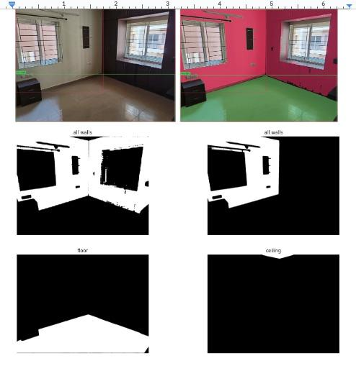

1. Layout Estimation:

Layout estimation works by predicting the structure of a room from a single image. The goal is to identify key points, such as room corners and junctions, and connect them in the correct order to obtain the room layout. We have experimented with two models- LSUN-RoomNet and ST-RoomNet. RoomNet, an end-to-end trainable encoder-decoder network, for room layout estimation from a monocular RGB image, directly formulates the problem as one of estimating an ordered set of room layout key points, eliminating the need for separate semantic segmentation and iterative optimization steps. It predicts the locations of these key points, which completely specify the room layout and corresponding segmentation. ST-RoomNet uses spatial transformation networks (STN) to estimate room layouts from monocular RGB images. The method trains a convolutional neural network to predict unsupervised perspective transformation parameters that can transform a reference cuboid layout to the required room layout based on the deep features of the input room image. The spatial transformation networks utilize a combination of convolutional and fully connected layers to learn the necessary perspective transformation parameters. These parameters enable the network to accurately estimate the room layout by mapping the reference cuboid layout to the input room image. The proposed method achieves promising results in accurately estimating room layouts from monocular RGB images, as demonstrated in our experimental evaluations. Both the models are trained on limited cases, but the nature of the resultant image differs them in terms of efficiency, from Fig 3 we can derive the result that ST-RoomNet has better edge quality compared to LSUN-RoomNet which makes it efficient.

1. Layout Processing

To achieve a realistic texture replacement effect, it is essential to accurately map the desired texture to the specific points of the surface where it will be projected. This process involves several steps, including.

1. Extracting the layout coordinates of the area where the texture will be mapped.

2. Classifying the layout coordinates as corner and outer points.

3. Forming coordinate sets that correspond to each wall or floor surface using the recovered coordinates from step 2.

4. Applying the tilted texture to the input image using a texture mapping technique

In summary, the proposed approach involves a multi-step process that leverages state-of-the-art image processing techniques to accurately map the desired texture to the specific area of the surface where it will be projected, resulting in a visually appealing and realistic texture replacement effect.

a b c d e

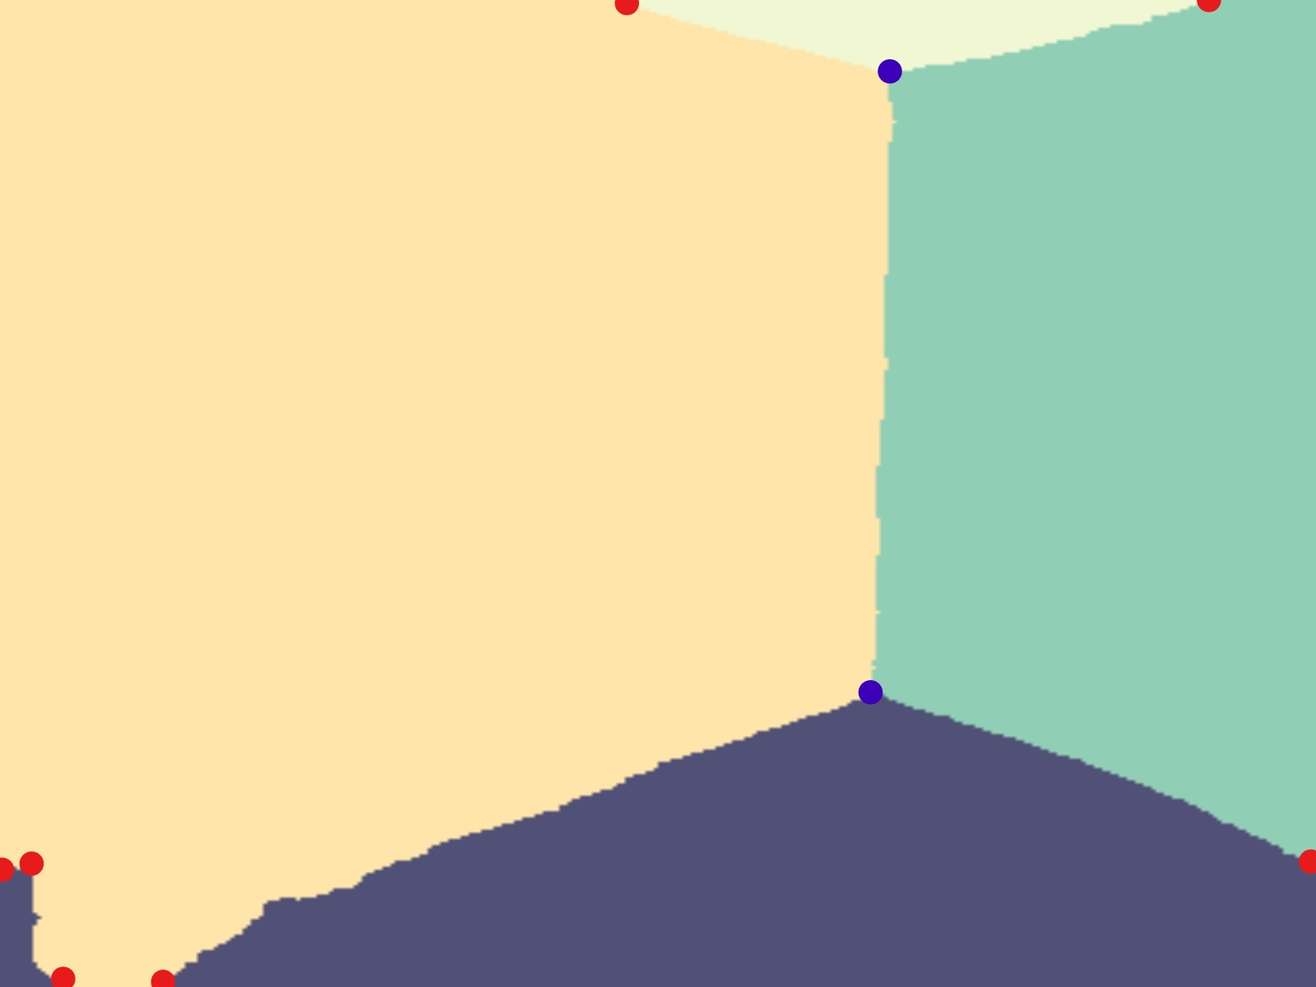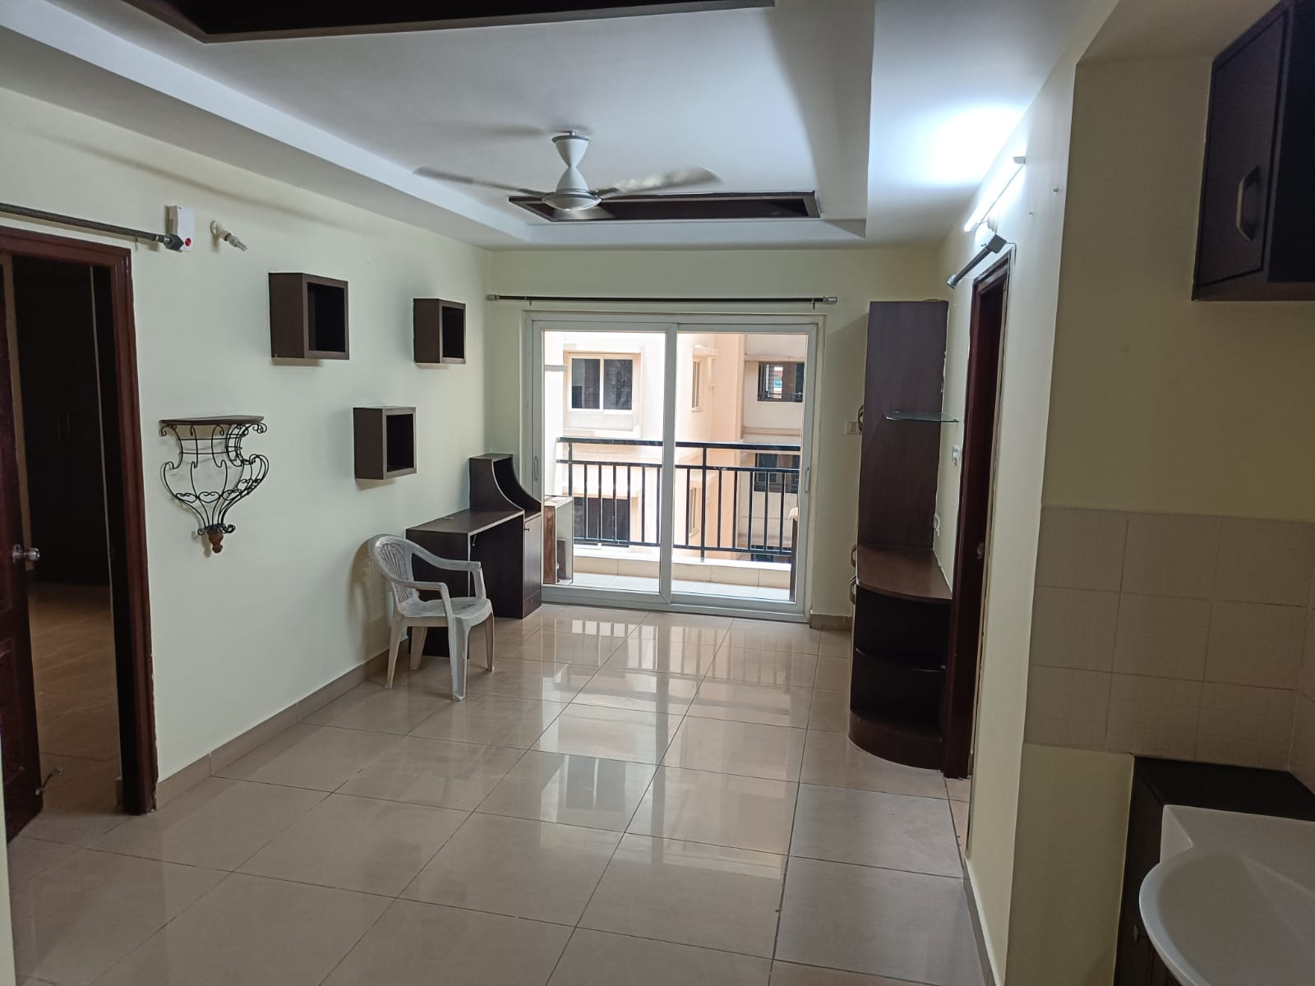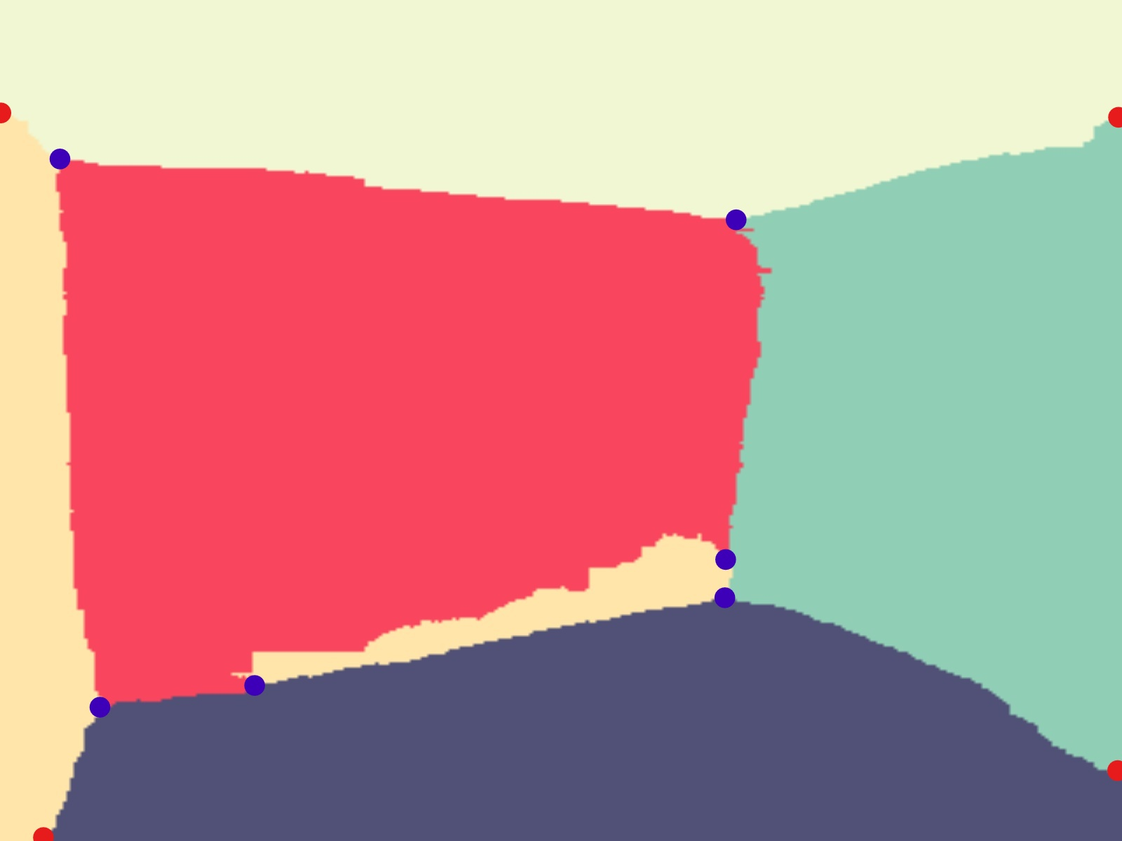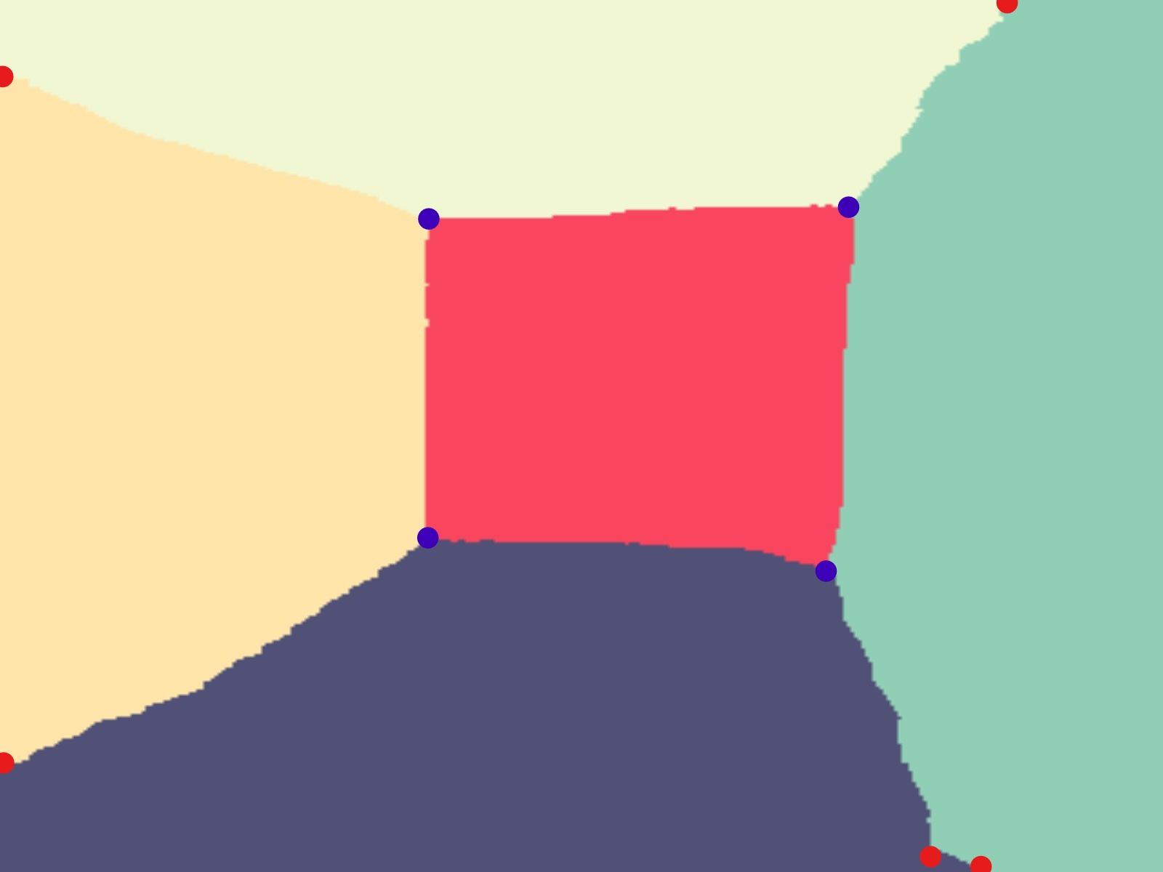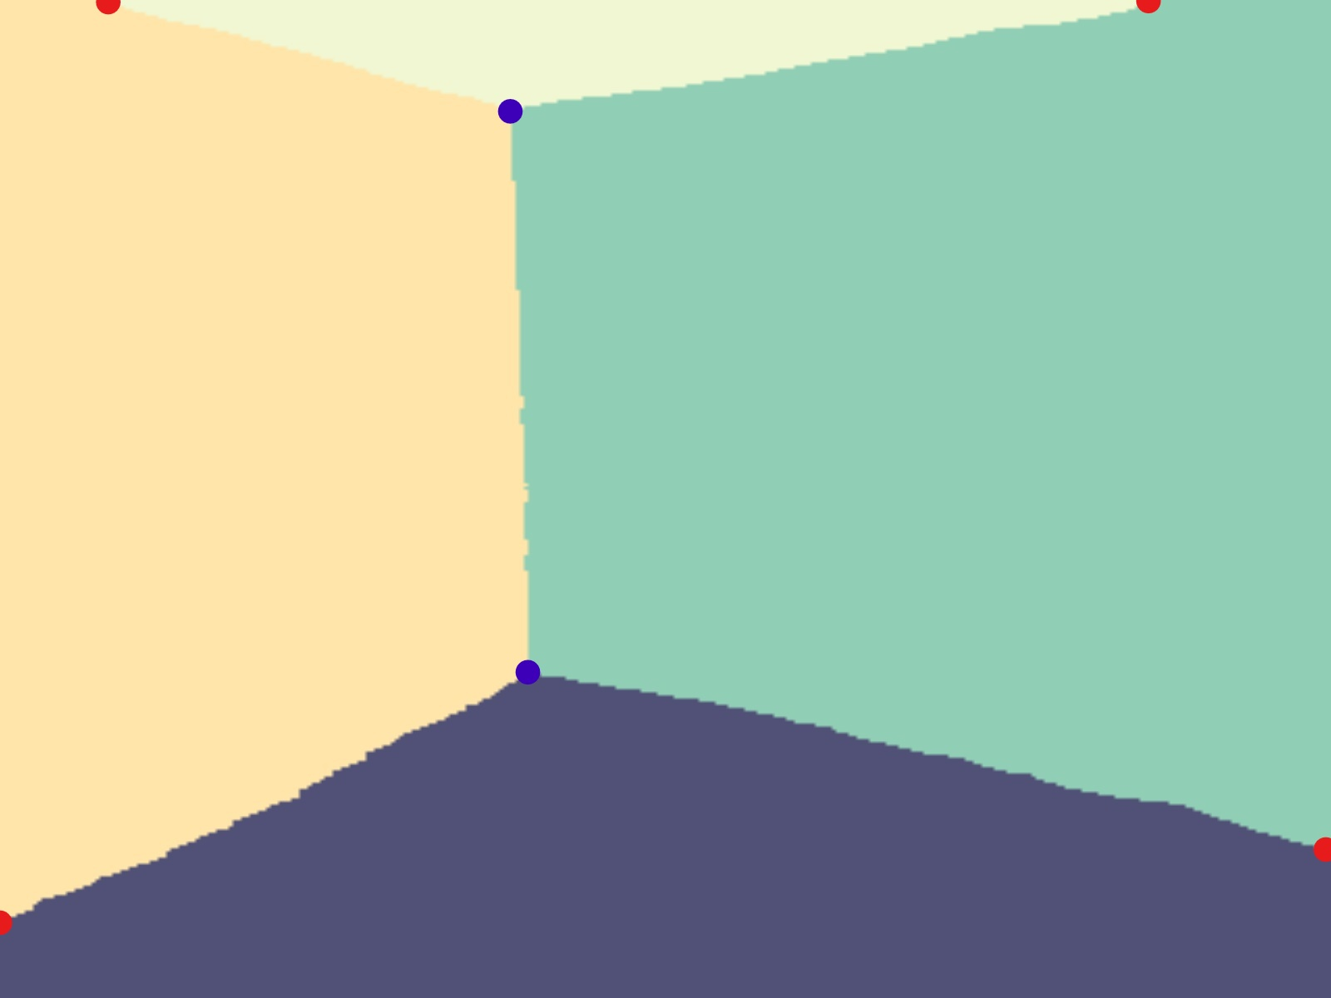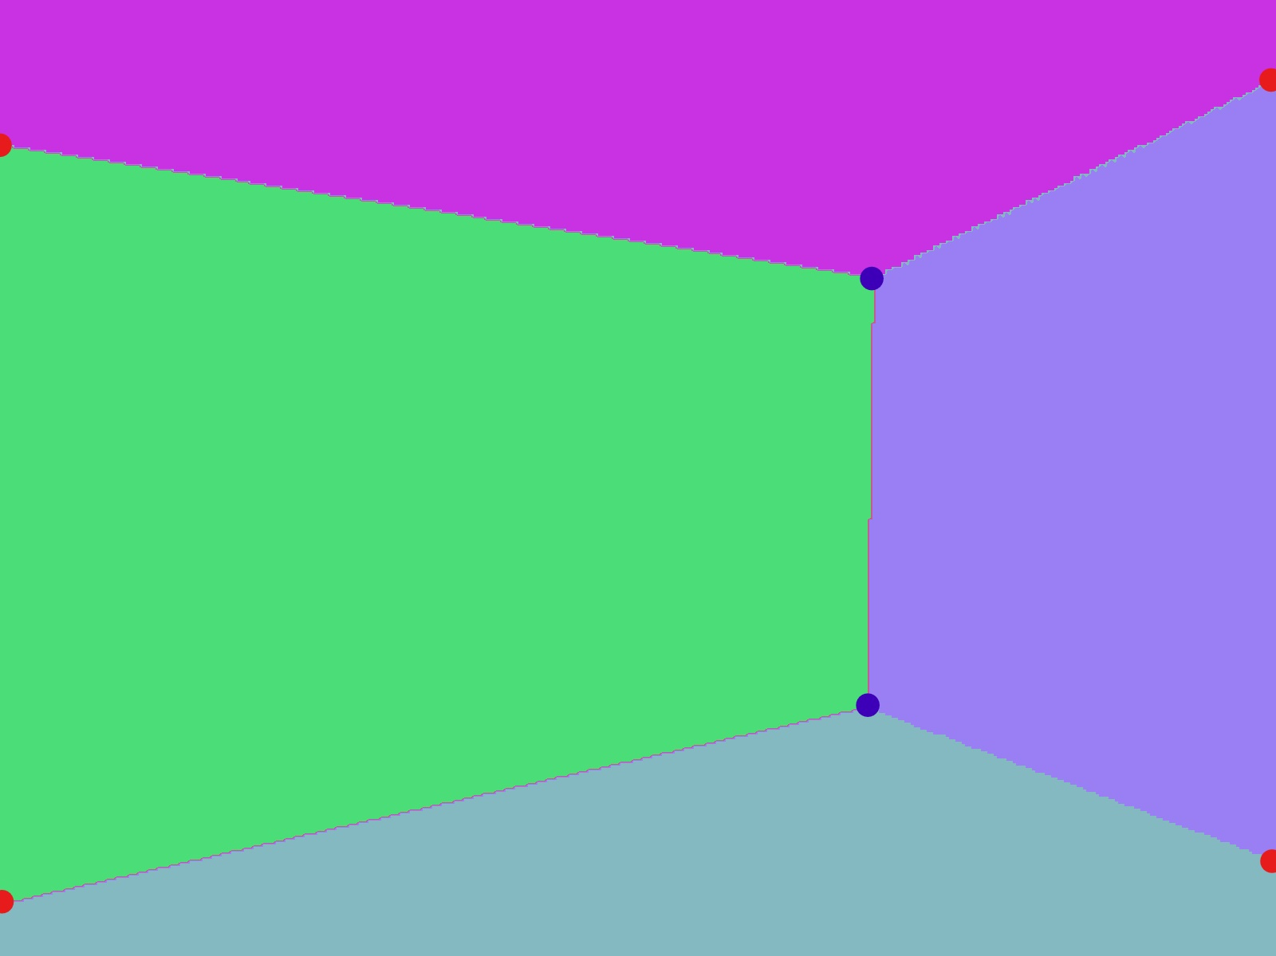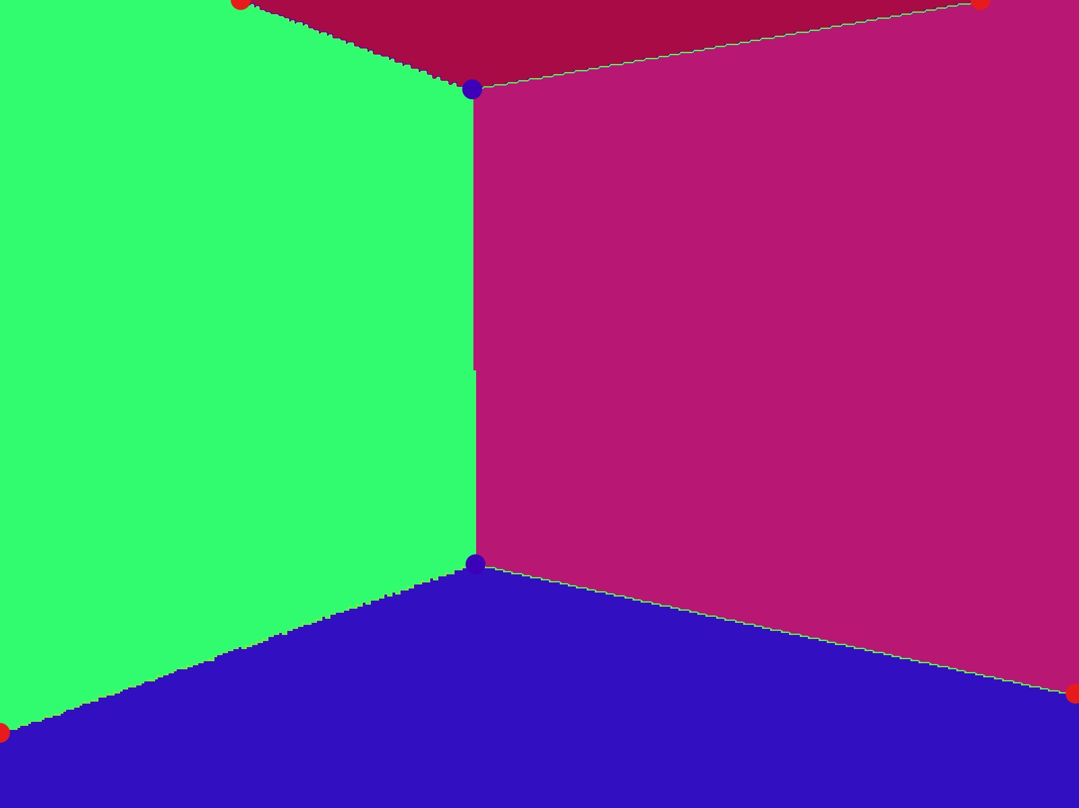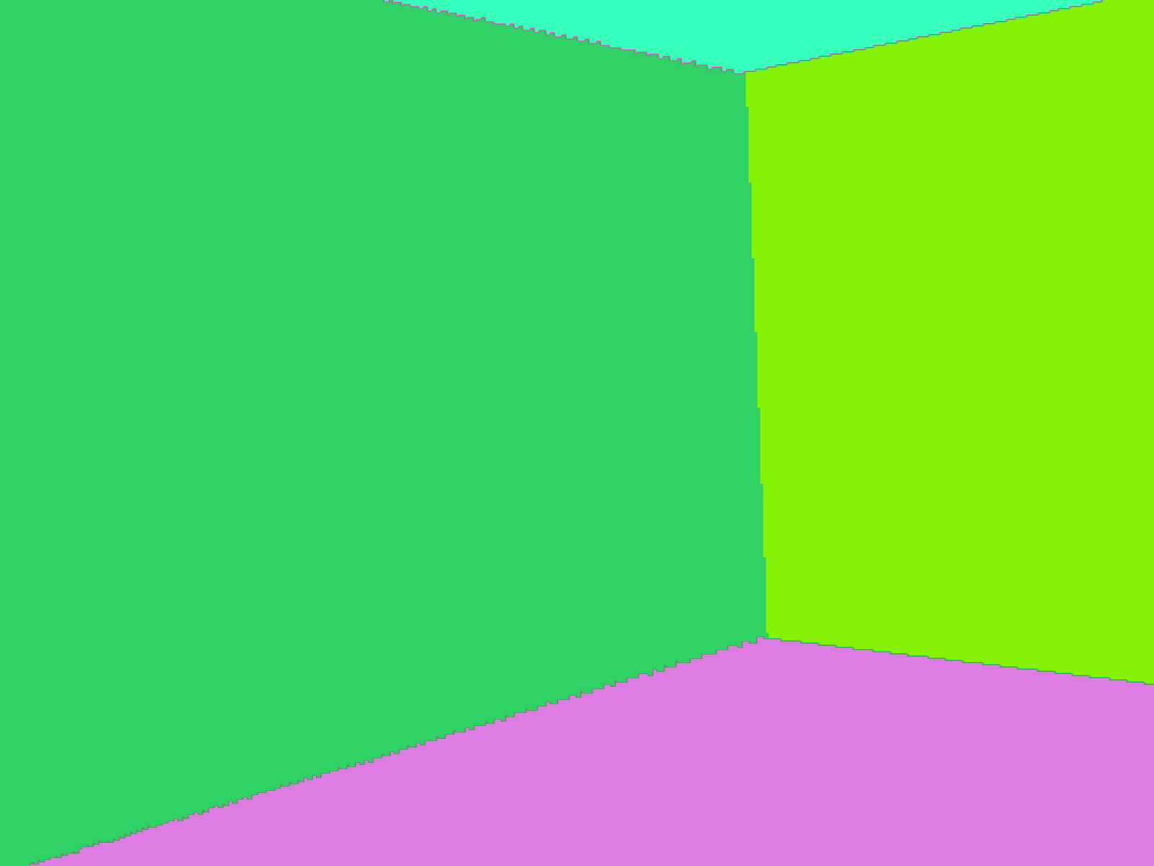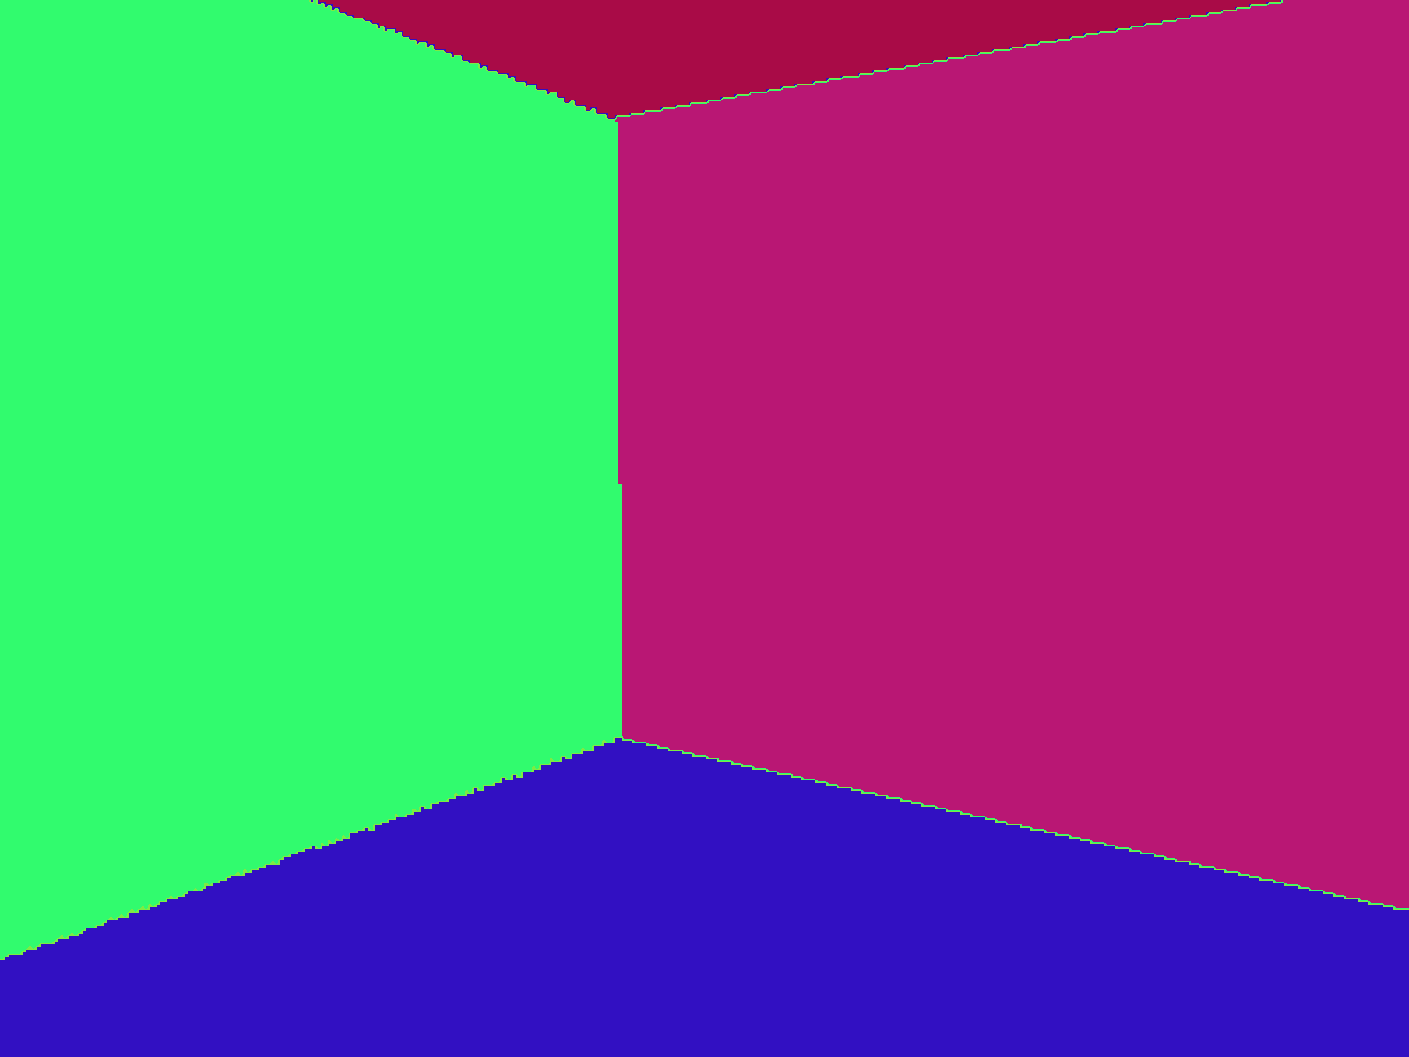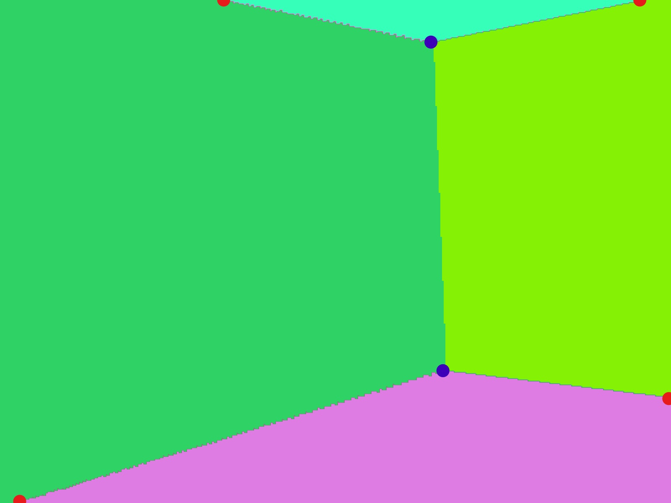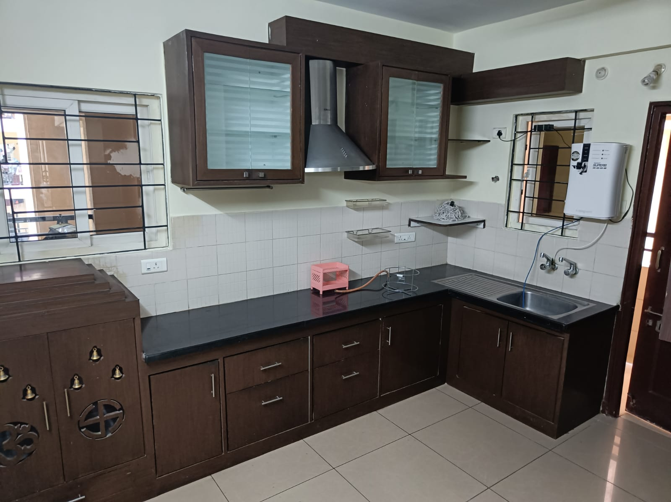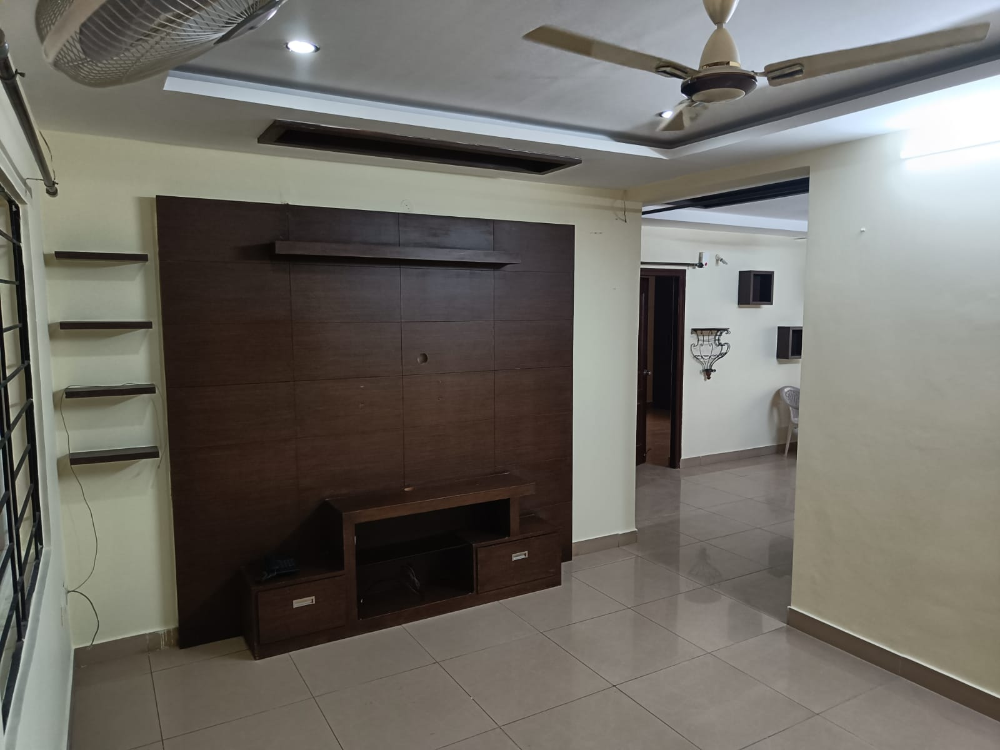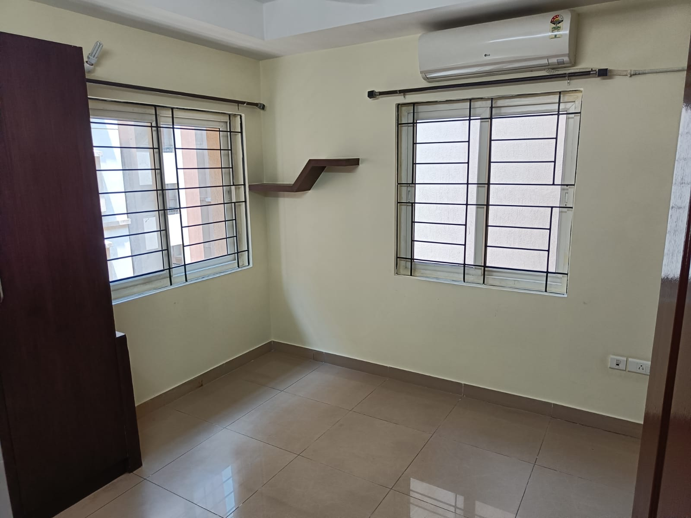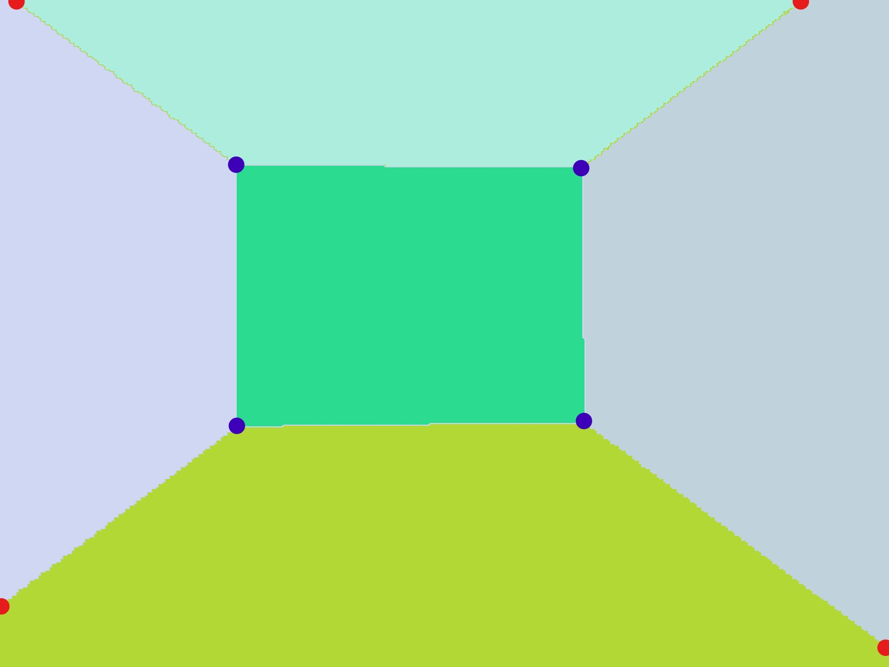

Fig 3: Comparison of results of LSUN-RoomNet (left) and ST-RoomNet (right) and its effect on key-point extraction.

a. Input image b. LSUN-RoomNet layout estimation c. LSUN-RoomNet key point Classification d.ST-RoomNet layout estimation e.ST-RoomNet key-point Classification

1. Key-Point Extraction and reduction:

The first step is Key-point Extraction. To facilitate this, we employ the Canny edge detection technique to identify the edges of the wall and the Harris corner detection algorithm [21] to reduce the number of edge points to a manageable level using the Douglas-Peucker algorithm [22]. This allows us to accurately determine the position and angle of the corner points of surfaces, enabling the creation of a realistic texture replacement image.

This result will consist of a lot of noise points, which must be removed to a minimal number.

For this, 2 steps are followed,

1. Remove the duplicate points, where the x and y coordinates of multiple points are the same.
2. Then, a distance threshold is fixed, and the points that are too close to each other having their distance less than the threshold are also removed.

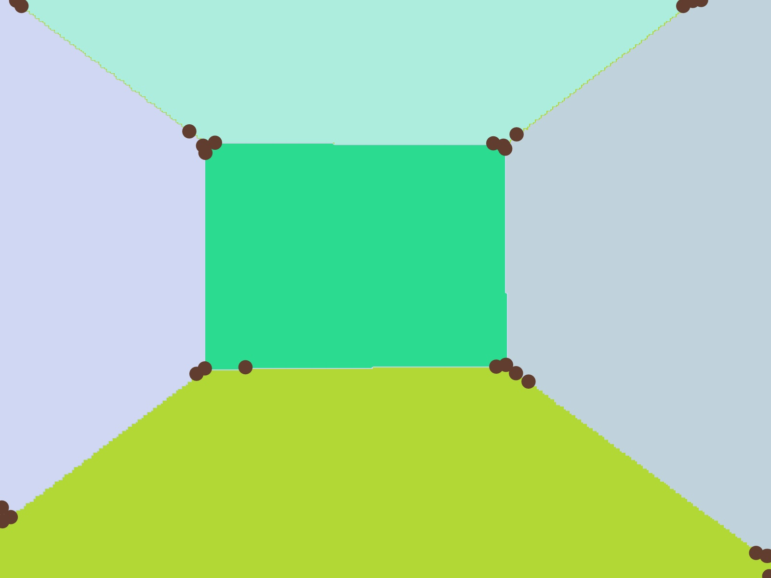

Fig 4: Output from the key-point extraction step

Here in Fig-4, it is evident that most of irrelevant points have been reduced with the help of distance thresholding and duplicate removal. However, some of the irrelevant still need to be removed.

1. Key point Classification:

Classifying the extracted points as Corner and Outer points is the process carried out in this step. This step plays a crucial role in carrying out the formation of coordinate sets in the next step.

The Corner points indicate the precise location where the walls intersect. On the other hand, the Outer points, located at the edge of the image, provide information about the wall's extreme corner, thereby offering crucial details about the dimensions and intersection of the walls.

Multiple layers of a completely novel mathematical solution are developed for this task. It involves following steps:

1. Classifying the outer and corner points
2. Clustering the corner points and reducing the noise from each cluster of corner points, depicted in Fig-5a.
3. Correcting the Outer points

After all these steps, the final resultant image shown in Fig 5b,

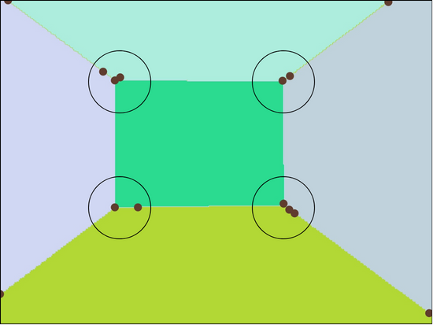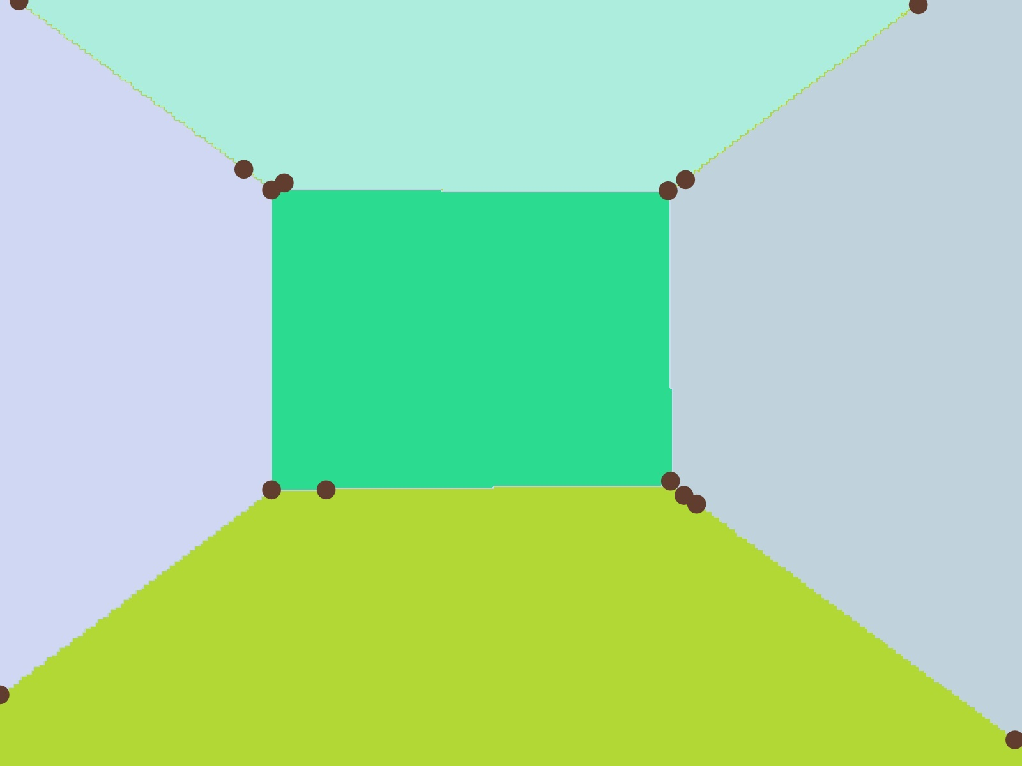

Fig 5: a. result from corner reduction (top) b. clustering of key points (bottom)

After all these steps, the final resultant image will be as follows in Fig 6,

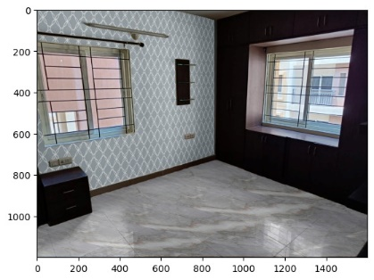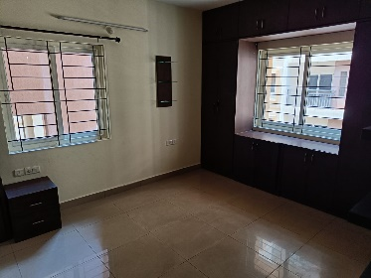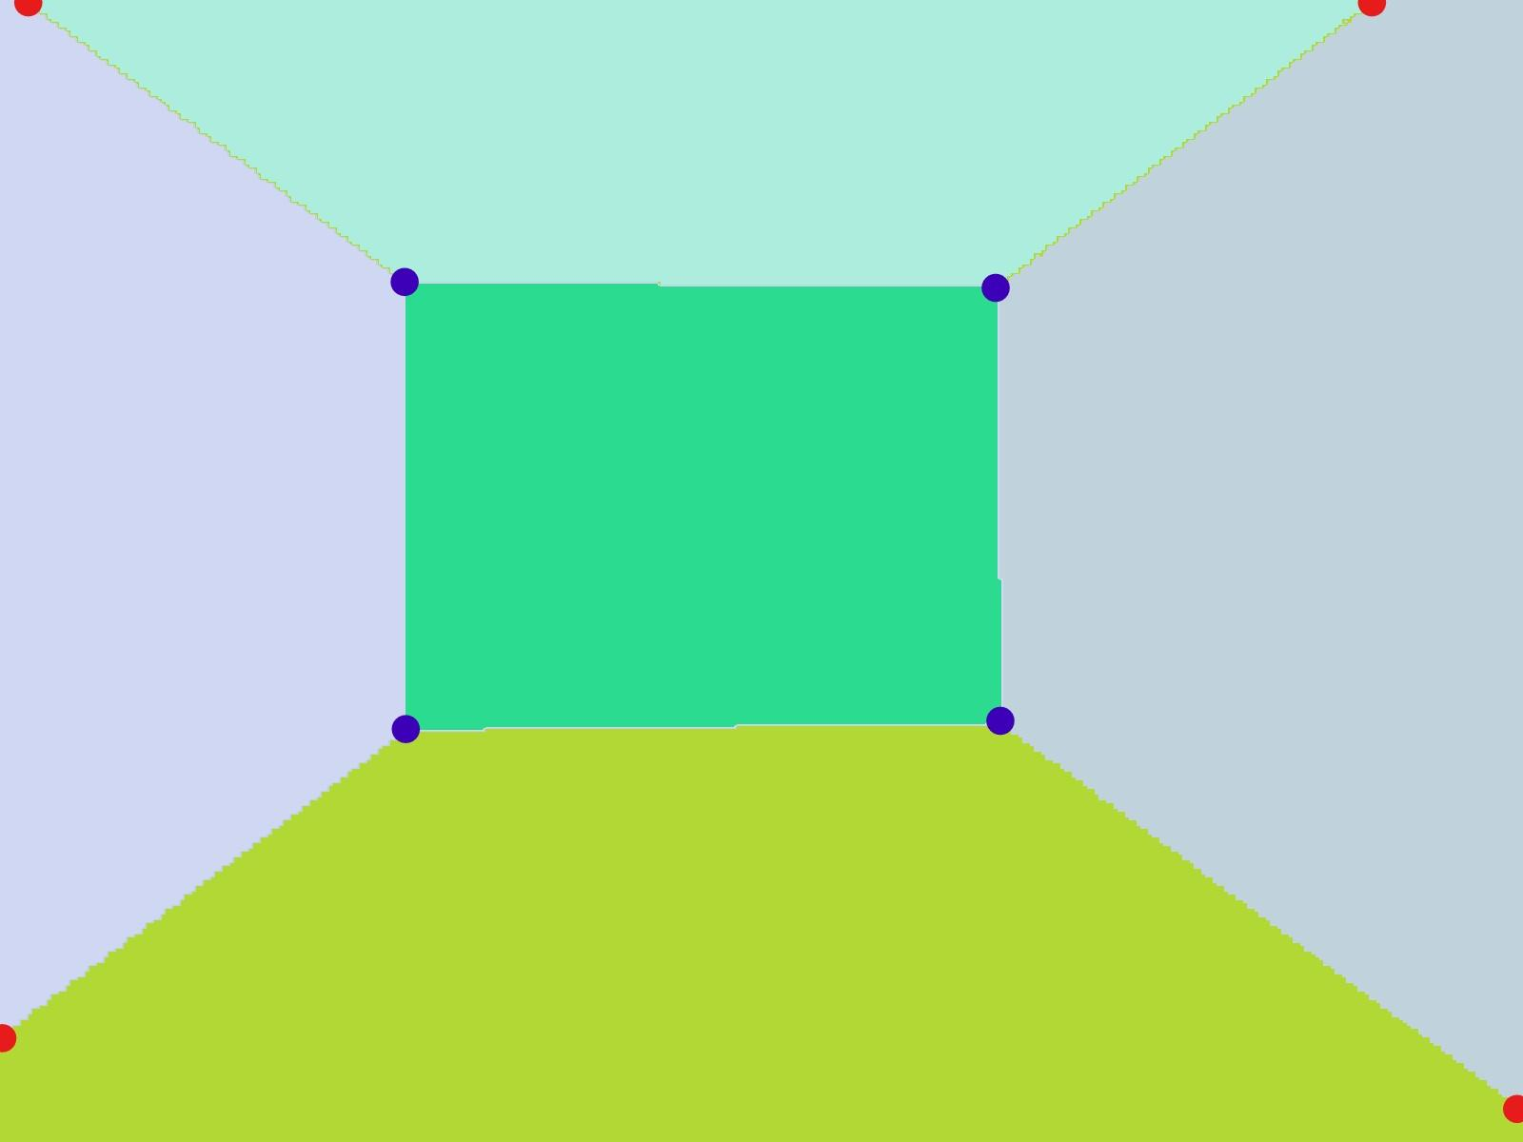

Fig 6: Right point indicates Outer and Blue indicates Corner point.

1. Lightings and Shadow Extraction:

To give a realistic quality to the subsequent depiction, we have replicated the brightness intensity from the source depiction and added weight to the subsequent outcome. This magnitude of weight is initialized by the user to select a more precise alternative. The brightness intensity of the source depiction can be captured by converting the RGB to HSV format and discarding the Hue and Saturation components.

G. Overlayer:

This module is responsible for delivery of the resultant image. It collects necessary information from the prior modules and user-interested components to alter specific texture of the original image, merges with the original image using OpenCV tool.

1. Results

The tool that we have developed has the remarkable capability to bring about changes in particular textures, specifically those that are chosen by the user, in an impressively short span of 30 seconds to be exact. Moreover, this tool is not restricted to merely one category of interior scene, but instead, it is created to function optimally and successfully with an assortment of interior scenes.

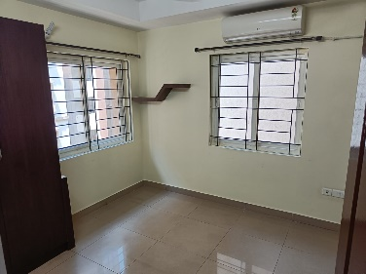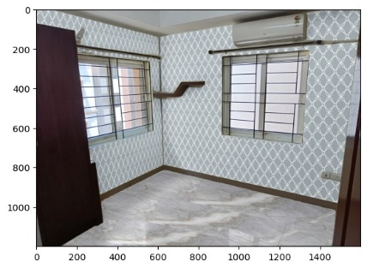

Fig 7 – Resultant Image

1. Future Works

Performance of this tool can be improved by incorporating following points:

1. By Fine-tuning Grounded-SAM with appropriate dataset
2. Integrating a better Layout estimation model and its ability to work on most of the cases.
3. Deriving a more generalized method to extract key-points.
4. Addition or modification modules of the proposed pipeline.

VI. REFERENCE

1. S. Dasgupta, K. Fang, K. Chen and S. Savarese, "DeLay: Robust Spatial Layout Estimation for Cluttered Indoor Scenes," 2016 IEEE Conference on Computer Vision and Pattern Recognition (CVPR), Las Vegas, NV, USA, 2016, pp. 616-624, doi: 10.1109/CVPR.2016.73.
2. RoomNet: End-to-End Room Layout Estimation Chen-Yu Lee, Vijay Badrinarayanan, Tomasz Malisiewicz, Andrew Rabinovich <https://doi.org/10.48550/arXiv.1703.06241>
3. Manhattan Room Layout Reconstruction from a Single 360 image: A Comparative Study of State-of-the-art Methods <https://doi.org/10.48550/arXiv.1910.04099>
4. H. J. Lin, S. -W. Huang, S. -H. Lai and C. -K. Chiang, "Indoor Scene Layout Estimation from a Single Image," 2018 24th International Conference on Pattern Recognition (ICPR), Beijing, China, 2018, pp. 842-847, doi: 10.1109/ICPR.2018.8546278.
5. Mohan, N., & Kumar, M. (2022). Room layout estimation in indoor environment: a review. Multimedia Tools and Applications, 1-31.
6. Ibrahem, H., Salem, A., & Kang, H. S. (2023). ST-RoomNet: Learning Room Layout Estimation From Single Image Through Unsupervised Spatial Transformations. In Proceedings of the IEEE/CVF Conference on Computer Vision and Pattern Recognition (pp. 3375-3383).
7. “Segment Anything” Alexander Kirillov, Eric Mintun, Nikhila Ravi, Hanzi Mao, Chloe Rolland, Laura Gustafson, Tete Xiao,Spencer Whitehead, Alexander C. Berg, Wan-Yen Lo, Piotr Dollár, Ross Girshick <https://doi.org/10.48550/arXiv.2304.02643>
8. Unsupervised Spatial Transformations," 2023 IEEE/CVF Conference on Computer Vision and Pattern Recognition Workshops (CVPRW), Vancouver, BC, Canada, 2023, pp. 3376-3384, doi: 10.1109/CVPRW59228.2023.00340.
9. Wang, A., Wen, S., Gao, Y. et al. Toward Enhancing Room Layout Estimation by Feature Pyramid Networks. Data Sci. Eng. 7, 213–224 (2022). <https://doi.org/10.1007/s41019-022-00192-6>
10. Liu, S., Zeng, Z., Ren, T., Li, F., Zhang, H., Yang, J., ... & Zhang, L. (2023). Grounding dino: Marrying dino with grounded pre-training for open-set object detection. arXiv preprint arXiv:2303.05499.
11. Zhang, H., Li, F., Liu, S., Zhang, L., Su, H., Zhu, J., ... & Shum, H. Y. (2022). Dino: Detr with improved denoising anchor boxes for end-to-end object detection. arXiv preprint arXiv:2203.03605.
12. Yang, S. T., Wang, F. E., Peng, C. H., Wonka, P., Sun, M., & Chu, H. K. (2019). Dula-net: A dual-projection network for estimating room layouts from a single rgb panorama. In Proceedings of the IEEE/CVF Conference on Computer Vision and Pattern Recognition (pp. 3363-3372).
13. Zou, C., Colburn, A., Shan, Q., & Hoiem, D. (2018). Layoutnet: Reconstructing the 3d room layout from a single rgb image. In Proceedings of the IEEE conference on computer vision and pattern recognition (pp. 2051-2059).
14. Mallya, A., & Lazebnik, S. (2015). Learning informative edge maps for indoor scene layout prediction. In Proceedings of the IEEE international conference on computer vision (pp. 936-944).
15. Song, S., Lichtenberg, S. P., & Xiao, J. (2015). Sun rgb-d: A rgb-d scene understanding benchmark suite. In Proceedings of the IEEE conference on computer vision and pattern recognition (pp. 567-576).
16. Dai, A., Chang, A. X., Savva, M., Halber, M., Funkhouser, T., & Nießner, M. (2017). Scannet: Richly-annotated 3d reconstructions of indoor scenes. In Proceedings of the IEEE conference on computer vision and pattern recognition (pp. 5828-5839).
17. Hua, B. S., Pham, Q. H., Nguyen, D. T., Tran, M. K., Yu, L. F., & Yeung, S. K. (2016, October). Scenenn: A scene meshes dataset with annotations. In 2016 fourth international conference on 3D vision (3DV) (pp. 92-101). Ieee.
18. Silberman, N., Hoiem, D., Kohli, P., & Fergus, R. (2012). Indoor segmentation and support inference from rgbd images. In Computer Vision–ECCV 2012: 12th European Conference on Computer Vision, Florence, Italy, October 7-13, 2012, Proceedings, Part V 12 (pp. 746-760). Springer Berlin Heidelberg.
19. Young, P., Lai, A., Hodosh, M., & Hockenmaier, J. (2014). From image descriptions to visual denotations: New similarity metrics for semantic inference over event descriptions. Transactions of the Association for Computational Linguistics, 2, 67-78.
20. Coughlan, J., & Yuille, A. L. (2000). The manhattan world assumption: Regularities in scene statistics which enable bayesian inference. Advances in Neural Information Processing Systems, 13.
21. Sánchez, Javier & Monzón, Nelson & Salgado, Agustín. (2018). An Analysis and Implementation of the Harris Corner Detector. Image Processing On Line. 8. 305-328. 10.5201/ipol.2018.229.
22. C.I.S.R., G., & Hon. (2013). The Douglas-Peucker Algorithm for Line Simplification through visualization.